Generic Staff Roster
Quick Start Guide

Welcome to the Quick Start Guide for Generic Staff Roster (hereafter referred to as GSR). While GSR is still in development, this document will serve as a 'manual by proxy' so to speak until the full manual and help file have been completed. These will be available to those users who register the program with the author.

Section 1. General Overview

GSR was designed to aid in the development of weekly staff rosters for small business owners/managers. GSR has the ability to produce reports which details any potential conflicts or problems found with your rosters. It can also produce very basic staff/roster cost breakdown reports.

GSR is composed of four main elements. These are:

- The Control Form

The control form has several functions. These are:
- allow modification of each roster description and code
- allow activation or deactivation of individual rosters
- adjust parameters of new rosters (start time, end time, interval)
- select the starting day of the week (Sunday through to Saturday)
- toggle delete confirmation
- delete all rosters

- The Staff Form

The staff form allows you to modify your staff member list. On this form, you can add new staff members and their details, edit details for existing staff members and delete obsolete staff records.

- The Roster Form

The roster form is your roster creation workspace. Here you can:
- adjust times for each shift in the roster
- add staff members to individual time slots
- remove staff members from individual time slots
- print the selected roster
- edit notes for the selected roster

- The Main Window

The main window contains all of the previous forms. It also provides a toolbar (at the top of the form) and a status bar (at the bottom of the form). The toolbar contains buttons to:
- show or hide the staff, roster and control forms
- print the selected form (if applicable)
- change the font for the selected item
- produce the roster Exception Report
- produce the staff/roster detail report

The status bar contains information about the operation of GSR (generally whichever control the mouse cursor is over).

Rosters and Shifts

A roster is made up of seven days (starting with the day specified on the control form). Each roster can contain an almost unlimited number of shifts. A shift comprises a start time and a finish time. A roster may also be called a 'classification' or 'class'. This is because you can allocate staff members to various rosters according to their classification. This is explained further in the section on the Staff form.

Section 2. Getting Started

The Control Form

The first task which you should concentrate on is defining the rosters or classes which your business requires. This is done on the control form. On the left hand side of the control form is a grid with three columns. Initially, this grid will be filled with default values and all rosters will be enabled.
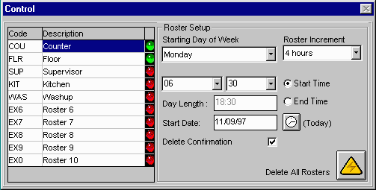
- Double-click on the first cell in the 'Description' column and a class definition text box will popup.

- Type in up to 20 alphanumeric characters as a description for this roster. You might use 'Counter' as an example of a counter roster for a small cafe. Click on the OK button to accept this description.

- Now double-click on the first cell in the 'Code' column. Again, a text box will popup asking for a short code to identify this roster.

- Type up to three alphanumeric characters in this box and click OK. You might type 'COU' as the short form for the counter roster example from step 2.

- Double-clicking on the small LED icon in the third column will activate (green) or deactivate (red) the roster. This means that the roster will not be available for editing on the roster form, or searched when exception or staff reports are produced.

Tip: Disabling all unnecessary rosters will speed up the reporting process.

- Repeat steps 1 to 5 on subsequent lines of the grid until you have entered all required rosters. GSR can handle up to ten roster definitions. (This may change in future versions).

- Click on the drop down box under 'Starting Day of Week' and select the day which starts your roster.

- Select the appropriate roster increment from the 'Roster Increment' drop down box. This increment will only be used if you decide to auto-generate a roster using the button on the roster form.

- If you decide to auto-generate your rosters (if you use standard times and increments for your shifts), click on 'Start Time' and select the starting hour and minute from the two drop down boxes to the left. Click on 'End Time' and repeat this procedure.

- The 'Start Date' box contains the date which will be printed on staff rosters. Enter the starting date of the roster here, or click on the button marked '(Today)' to place today's date in the box.

- Make sure the 'Delete Confirmation' box is checked if you want to be asked to confirm every time you delete a staff member or roster item.

The Staff Form

After you have defined all of the rosters which you require, you need to enter your staff details.
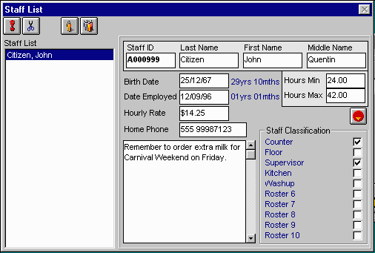
Select the staff form. There will be a default staff member already entered in the list, with the details for this employee displayed to the right. You can edit these details by clicking in the appropriate box and typing in the new details. If you make any changes to a staff record, the 'save' button becomes visible on the staff toolbar. This button has a small floppy disk icon on it. Click on this button to save any changes you have made to this staff member. The 'exclamation point' button on the staff toolbar is used to add a new staff member to the list, while the 'scissors' button is used to delete the highlighted staff member from the list.
Most of the staff details are self explanatory, but a few warrant further investigations.

Staff ID: this field should contain a UNIQUE staff alphanumeric code to identify each staff member. It is printed on each individual staff roster.

Birth Date and Date Employed: these fields are not required but if they are entered, 'age' and 'period employed' information will be displayed beside the respective fields.

Hours Min and Hours Max: these values are not required, but if entered, they will be used in the Exception Report to catch allocated hours which fall outside this range. For example, John Citizen has 'Hours Min' set to 24 and 'Hours Max' set to 42. If he is allocated 45 hours during the week, an exception will be reported when the Exception Report is produced. This is useful when certain staff members (e.g.: students) cannot work more than a set number of hours a week in case it interferes with their study allowance/assistance.

Notes: the notes box allows you to enter any reminders, messages etc for the selected staff member. This note is then printed on their individual weekly staff roster.

Staff Classification: The rosters which you entered in the control form will appear hear in a check box list. By checking a roster, you are making the selected staff member available to this roster. In the example above, John Citizen is available to be allocated to the Counter and Supervisor rosters. His name will not appear next to the other rosters on the roster form.
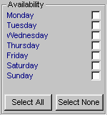
Staff Availability: Click the toggle button to switch between the Staff Classification frame and the Staff Availability frame. A list of days starting with the day specified on the control form will appear and you can check the days which the selected staff member is available on. This is a safety measure designed to eliminate staff being assigned to days they cannot regularly work. The two buttons at the bottom of the frame allow you to select all or none of the days quickly. Allocating staff to days for which they are unavailable on the roster form will result in a message box appearing, indicating that staff member is unavailable on the assigned day.

Both the Staff Classification and Staff Availability settings are used when the Exception Report is produced.

The last two icons on the Staff toolbar are used to print staff rosters. The first button will print a weekly roster for the selected staff member while the second button will print a weekly roster for all staff members who appear in rosters.

The Roster Form

The roster form is where you will spend most of your time once you have set up your staff list. The roster form consists of:

- a dropdown list box containing a list of all active rosters (those rosters whose LED light is green on the control form)
- a staff list box, containing all staff members who can be assigned to the selected roster (the checkbox for the roster is checked on the staff form)
- a spreadsheet-type grid where the roster is defined
- a small toolbar

By clicking on the dropdown list box, you can select from the list of rosters which you have marked active. After selection, the roster (if already defined) will appear in the spreadsheet grid and a list of all available staff members for this roster will appear in the staff list box.
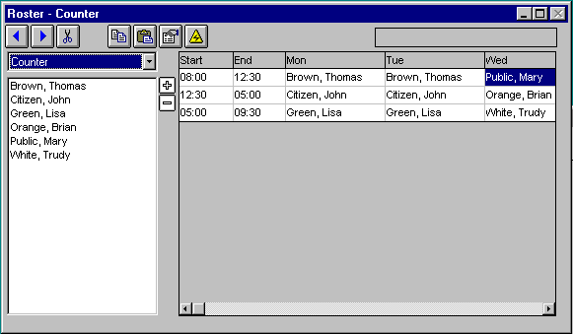
Once you have selected the desired roster, you can begin to modify it. Your first roster will require at least one shift, with a start time and a finish time. There are two ways of creating a new roster.

- You can click the auto-generate button on the roster toolbar (the little triangle with the lightning bolt). This will build a new roster using the defaults on the control form. It will start with the designated start time and build shifts with the increment specified until the end time is reached. This method is of most use when your shifts are of uniform length.

- If your roster shifts are somewhat less uniform, then you can define the shifts yourself. Select a blank line on the roster and double-click the first column. A small dialog box will popup allowing you to select the starting hour and minute for this shift. Select the appropriate time and press 'OK'. Repeat this process in the second column to create the end time. To create more shifts, click on the 'plus' button and a new row will be inserted in the grid. The 'minus' button will remove the selected row from the grid. Double-clicking on a grid cell with a time value in it will enable you to modify that time.

Now that you have the roster shifts set, you can begin to allocate staff members. The easiest way to perform this task is:

- Highlight the desired shift on the roster spreadsheet. Tip: You can highlight more than one cell by clicking and holding the left mouse button while dragging the mouse cursor. Use this method to select the same shift across several days.

- Select the staff member to be assigned to this shift. Tip: You can highlight more than one staff member by clicking and holding the left mouse button while dragging the mouse cursor. Hold down the control key and left-click to select/deselect multiple staff members.

- If you have selected a single staff member to transfer, double-click the staff name and it will be placed in the appropriate cell(s) in the roster. If the staff member is unavailable for that day, a dialog box will popup and tell you so.

- If you have selected multiple staff members to transfer, click on the right arrow button above the roster selection box. This will transfer all staff members into the selected roster cell(s). If a staff member is unavailable for that day, a dialog box will popup and tell you so.

- To remove a staff member from a shift, select the roster cell(s) and double-click the staff member’s name.

- To remove multiple staff members, select the roster cell(s) and multi-select the names of the staff members you wish to remove, then click upon the left arrow button above the roster selection box.

- Staff names can not be added to the same shift twice.

The Roster Toolbar

(from left to right)

- Delete - delete the entire contents of the selected cell.

- Save - save any changes made to this roster (this button is only visible after changes have been made to the current roster).

- Copy - copy the selected roster cells to the clipboard. Use this in conjunction with the paste command to duplicate sections of the roster.

- Paste - paste the contents of the clipboard into the selected roster cells. This command works best if the paste area is the same size as the copy area was. Note: this command will not paste multiple names

- Notes. - edit notes for the currently selected roster. These notes will be printed on the roster printout.

Section 3. Advanced Topics

Printing Rosters

To print a roster, select the desired roster from the roster selection box and click the printer button on the main form toolbar. This will print the current full-week roster, setting the start date to that defined on the control form. Any notes for this roster will be printed at the end of the report.

Printing Timesheets

You can print individual timesheets for a selected staff member, or all timesheets for those staff members who have been assigned to rosters. These buttons are available on the staff form toolbar.

Select the single staff button (on the left) to print out a single timesheet for the currently highlighted staff member. This timesheet will include any notes entered for that staff member.

Select the multi-staff button (on the right) to print single timesheets for all staff members allocated to a roster.

If a staff member hasn’t been allocated to a roster, no time sheet will be printed.

Producing Reports

The report functions in GSR are useful tools for reducing roster errors. The report buttons are located on the main form toolbar.

The Exception Report
Clicking on the left button (the button with the magnifying glass icon) will produce the ‘Exception Report’. The Exception Report will provide the most help when building your rosters. You should use it after you have finished your initial staff to roster allocation. Because this report has to cycle through all staff records and active rosters and perform multiple comparisons, it may take a few minutes to complete (depending upon the number of records and the processor type and memory capacity of the computer you are using). This report details:

- any staff conflicts across rosters, where a staff member may be allocated to multiple rosters on overlapping shifts

- unavailable staff members, where staff have been allocated on days which they are now not available (possibly on holiday, changed work hours etc)

- incorrect staff class, where staff have been allocated to rosters which they are now not available for (promoted, relieved of duties)

- staff member not in staff list, where a name was found in the roster and no corresponding staff member exists in the staff list (staff member retired, quit, employment terminated, changed name)

- allocation of hours incorrect, where a staff member requires certain hours and these requirements have not been met (too many hours, too few hours)

The report is shown in a spreadsheet grid similar to that of the roster, with the exceptions listed in the order in which they were found (normally staff member X roster X time). You can send this report to the printer by clicking on the printer icon on the main form toolbar. This report shows:

- an LED to indicate the severity of the problem (red, yellow or green – the color is only a basic interpretation of the possible eventualities the exception may cause)
- the roster name where the problem occurred
- the roster day and the
- shift start time when the problem occurred
- the staff member involved with the exception and
- a brief description of the problem.

Tip: You can double-click on an exception listed in the report to be taken to the source of the problem – either the roster form or the staff list – with the offending roster cell or staff member record highlighted.

The Staff Report
Clicking on the right button (the button with the faces icon) will produce the ‘Staff Report’. The Staff Report is most useful when you have allocated all of your staff to roster shifts. Because this report has to cycle through all staff records and active rosters and perform multiple comparisons, it may take a few minutes to complete (depending upon the number of records and the processor type and memory capacity of the computer you are using). This report details:

- total hours and currency amounts for each staff member broken down into each roster to which the staff member has been allocated

- grand total figures for each roster and absolute grand totals for all rosters

Note: if a staff member hasn’t been assigned an hourly rate, currency amounts will not be calculated for them. You can enter an hourly amount for a staff member on the staff form

The report is shown in a spreadsheet grid similar to that of the roster, with staff members listed in alphabetical order and then broken down by roster. You can send this report to the printer by clicking on the printer icon on the main form toolbar. This report shows:

- the staff members staff ID
- the staff members name
- the roster name applicable to the displayed hours and amount
- the hours for the specified roster (with total hours underneath for each staff member and a grand total at the end of the report)
- the total currency amount for the specified roster (with total amount underneath for each staff member and a grand total at the end of the report)
- a breakdown of hours and currency amounts for each roster at the end of the report

More About the Reports
The report form toolbar contains a query button (with a question mark icon). Click on this button to view more information about the highlighted exception or staff report.

Saving and Loading Files

Options

Section 4. System Requirements and Troubleshooting

GSR requires Windows 3.1or higher.

Section 5. GSR and the concept of Shareware

GSR is shareware. That means that you can download, use and completely free test the program for a certain period (normally 30-45 days). You may also freely copy and distribute GSR to others as long as the files in the original GSRxxx.ZIP archive are not tampered with and no fee is charged. If you find the program useful and you continue to use it, you are obligated to register.

The whole shareware concept is based on honesty. The registration fee you pay allows me to support and continue to develop GSR in the future.

When you register GSR you will get the most recent registered version of the program, with a bound copy of the manual and the registered version help file.

What is Shareware?

Shareware is the try it before you buy it concept of software marketing. It is freely available by downloading it from various BBS's, the Internet or one can easily and legally give a copy to a friend. If you like the software and intend on continuing to use it after the trial period of typically 30 - 45 days, you are expected to register the software with the author. Shareware is not freeware. It's continued use implies that it is a viable and needed tool. Registration encourages the author to enhance the software's features, making it a better tool for you the user, and also to create new software in the future.

Shareware distribution gives users a chance to try software before buying it. If you try a Shareware program and continue using it, you are expected to register. Individual programs differ on details -- some request registration while others require it, some specify a maximum trial period. With registration, you get anything from the simple right to continue using the software to an updated program with printed manual.

Copyright laws apply to both Shareware and commercial software, and the copyright holder retains all rights, with a few specific exceptions as stated below. Shareware authors are accomplished programmers, just like commercial authors, and the programs are of comparable quality. (In both cases, there are good programs and bad ones!) The main difference is in the method of distribution. The author specifically grants the right to copy and distribute the software, either to all and sundry or to a specific group. For example, some authors require written permission before a commercial disk vendor may copy their Shareware.

Shareware is a distribution method, not a type of software. You should find software that suits your needs and pocketbook, whether it's commercial or Shareware. The Shareware system makes fitting your needs easier, because you can try it before you buy it. And because the overhead is low, prices are also low. Shareware has the ultimate money-back guarantee -- if you don't use the product, you don't pay for it! :-)

Section 6. Ordering GSR

